**Docker Task -2**

**Step 1:- Creating docker file in Ec2 machine**

* Change to super user using the command

**Sudo su**

* Need to create a directory using the below command

**Mkdir docker-app**

* **Navigate to the directory using the command**

**Cd docker-app**

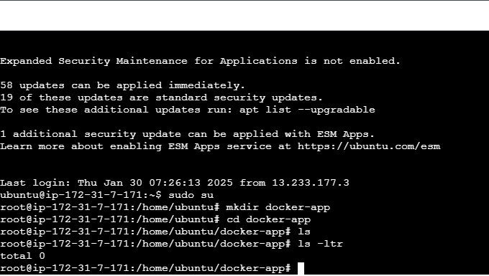

* Creating Python file using nano command to create app.py file

**Nano app.py** this file will have the sample application code

* Creating requirements file using nano command

**Nano requriements.txt** – this file will have the dependency for the application to run

* Creating a Dockerfile using the nano command

**Nano dockerfile**

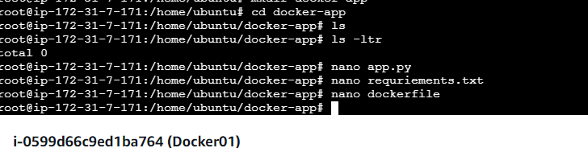

* Building the image using the dockerfile with the below command

**docker build -t docker-app1 .**

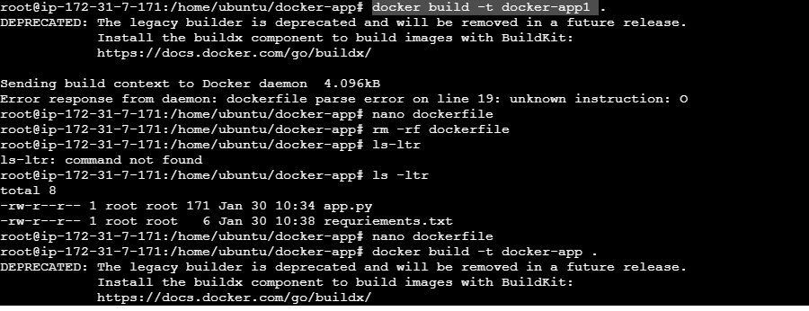

* Run the below command to list the images created

**Docker images**

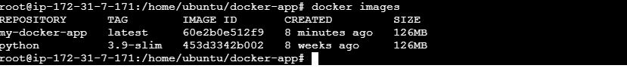

* Creating the container using the image that is created with the command

**Docker run –itd –p 5000:5000 docker-app**

* Run the below command to list the created container

**docker run -itd -p 5000:5000 my-docker-app**



* Now hit the IP in the browser with the port 5000

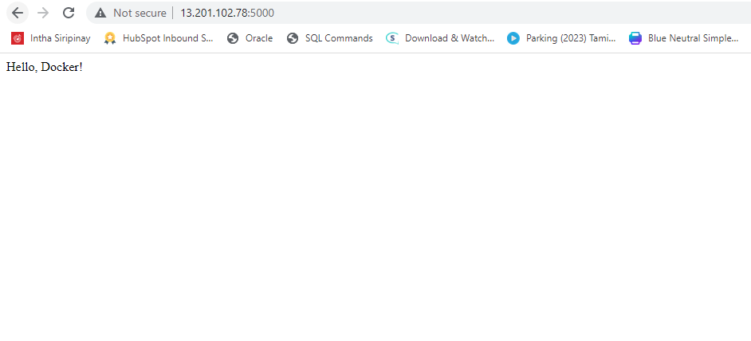

**Step 2:- creating docker compose in the EC2 machine**

* Create directory docker-compose using the below command

**Mkdir docker-compose**

* Navigate to the directory using the command below

**Cd docker-compose**

* Installing the docker compose as it will not be available in default using the command

**Apt install docker-compose**

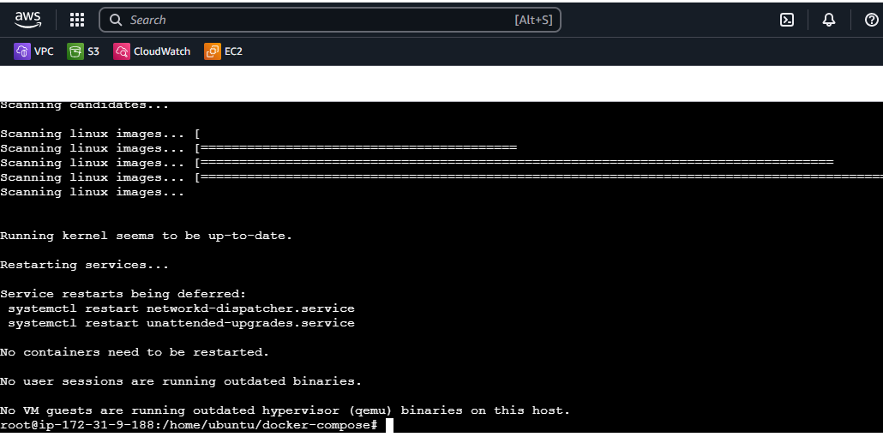

* Create directory web using the below command

**Mkdir web**

* Create index.html file using nano

**Nano index.html**

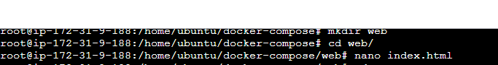

* Create docker-compose.yml file in the docker-compose directory using the nano command

**Nano docker-compose.yml**

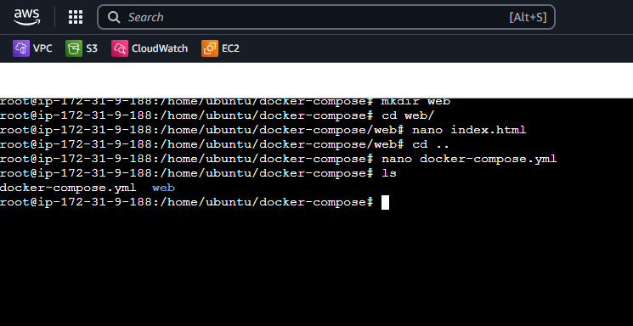

* Run below command to pull the image from the yml file and create container

**Docker-compose up –d**

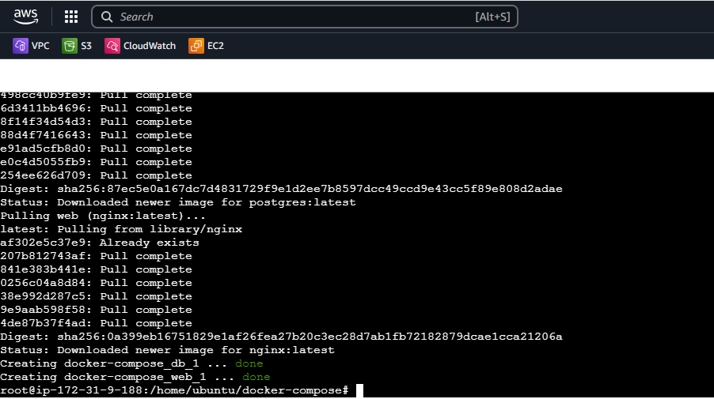

* Run the below command to list the containers created

**Docker ps**

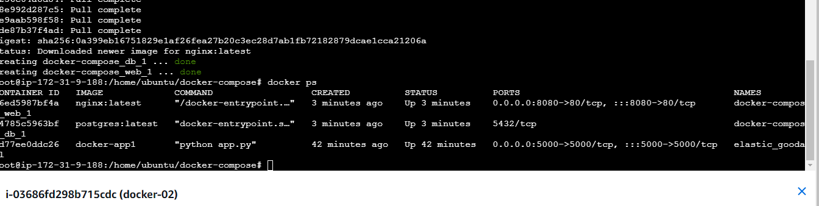

* Now hit the IP with the port 8080 specified in the yml file

